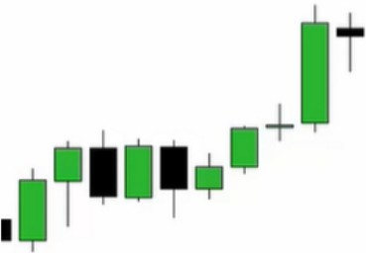**Anticipatory Skill Development**

Monthly charts will only move with great amount of money behind it Study every open high low and close of the last 3 months

Find the most recent down candle and then prior to the monthly downcandle what upcandle exists above it? Mark that then you have your trading range

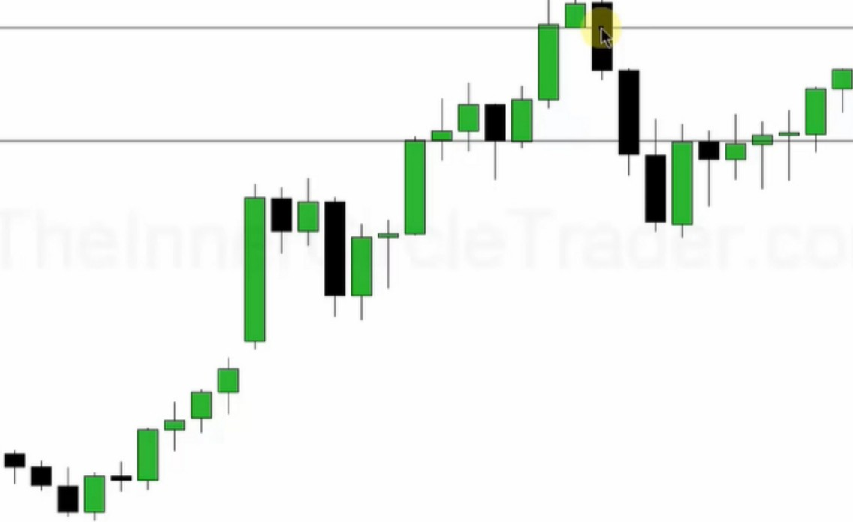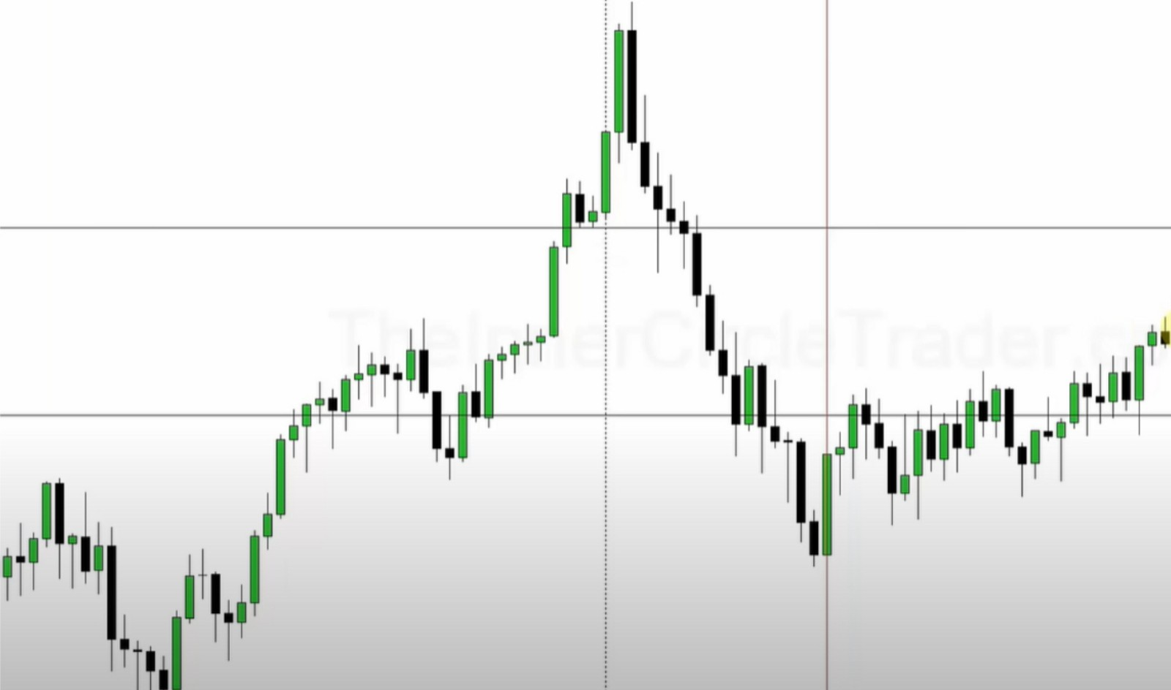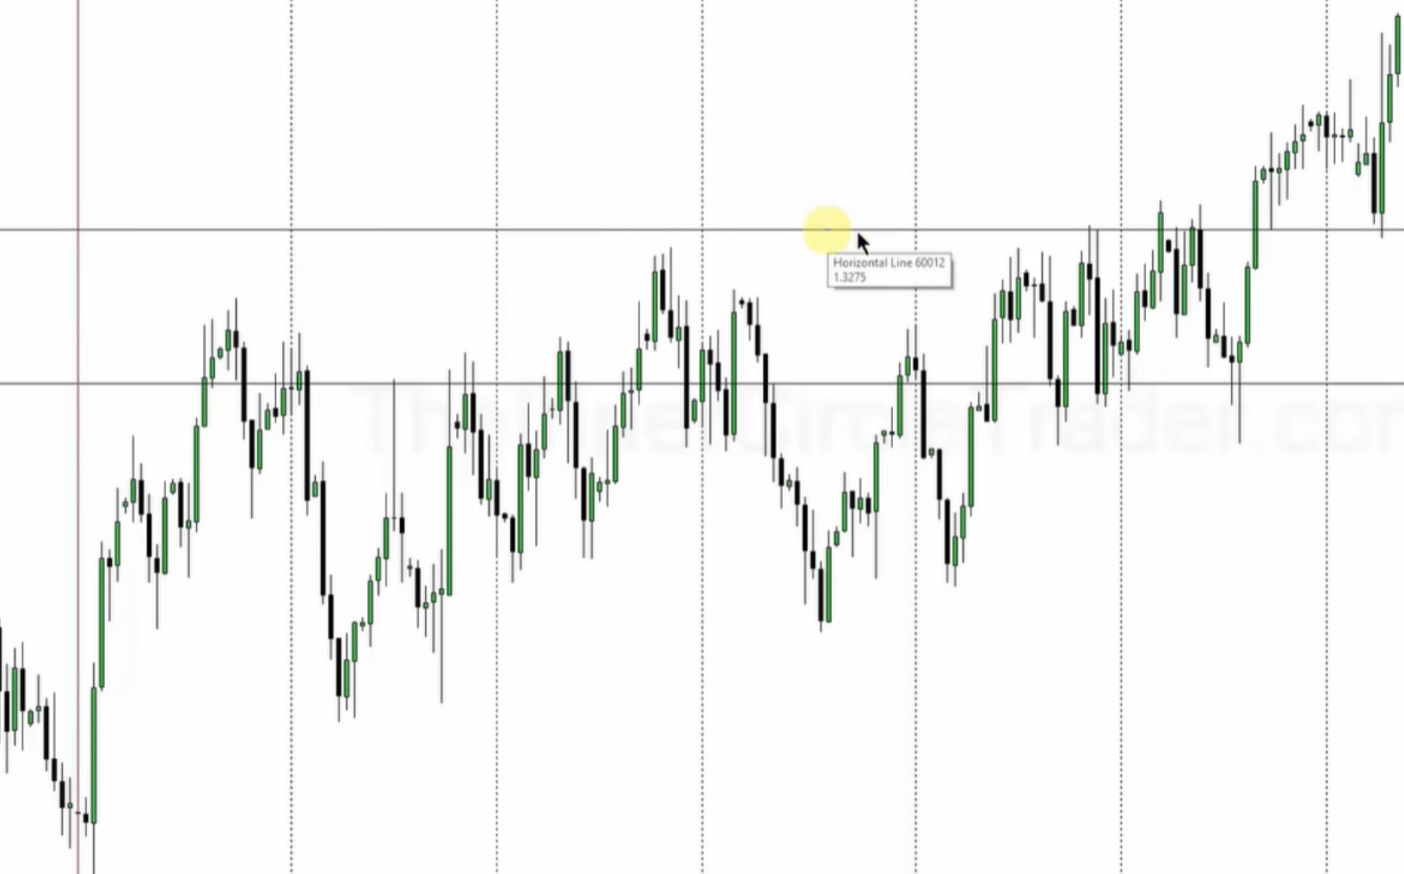

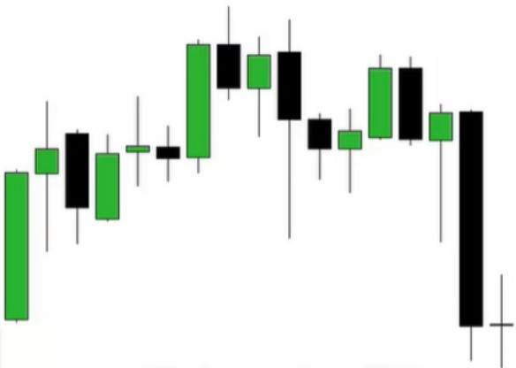The takeaway is this, when you mark the most recent downcandle and wait for it to trade above that you wait for a return to that open of the downcandle and you trade it to the last upcandle of your range

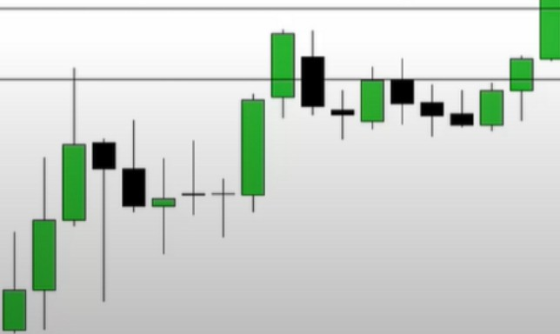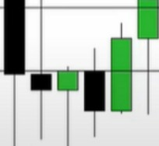

As soon as we trade above the downcandles high, the downcandle becomes a daily orderblock, so we can be a buyer at the open of the orderblock or less

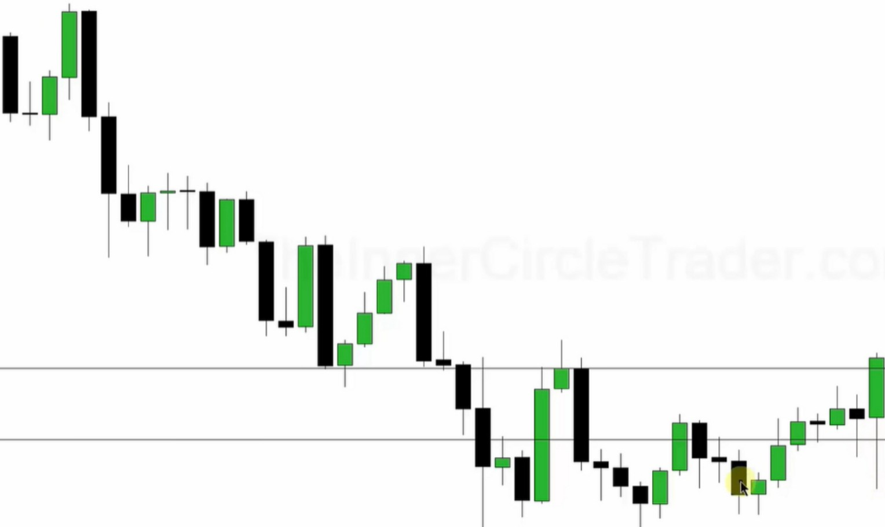

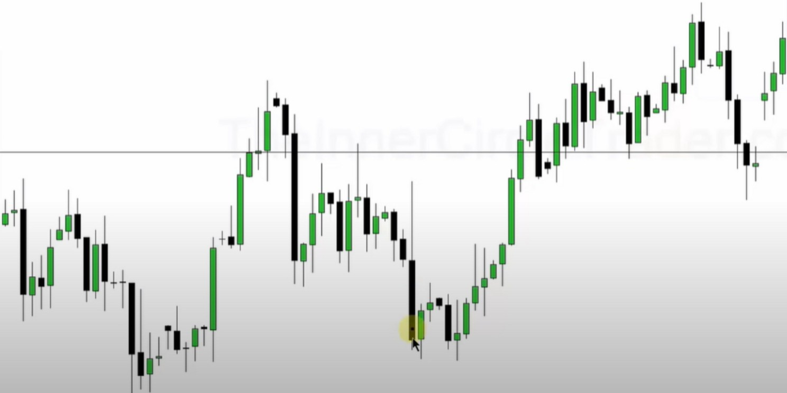

He uses the left orderblock because its larger then the one to the right

==-=,..-.•..1 1.....nn 1-J1,1.-.1.••1=--=a=w-a-1=1c•nn- .. 1•-•n u==-=o.•111-•n=-==uD,.o.c.a.u. ,,..,--•,....1,_ •1- n•--"• -•1&1W-1==11-•11 ,._.,.c-==,--• - **- U**

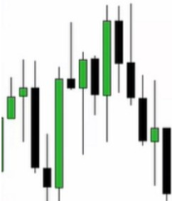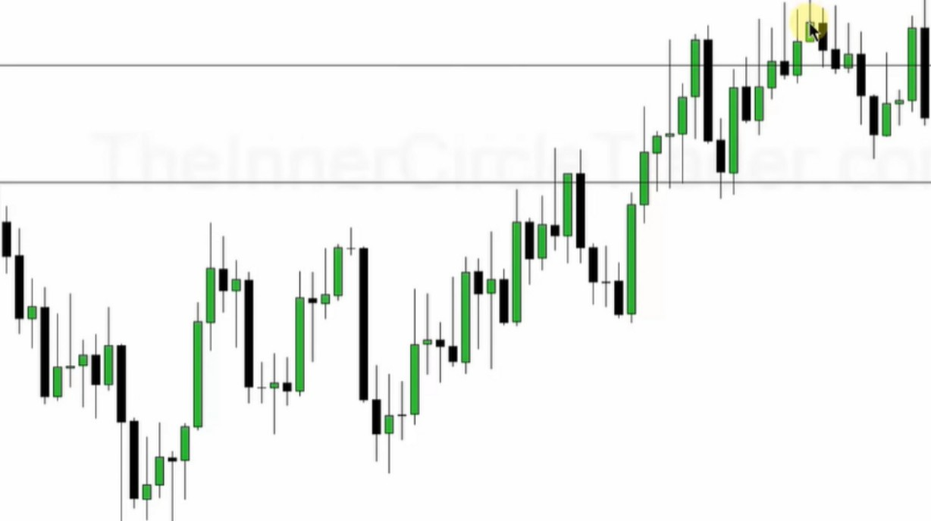

't

.**u**.

**u**

.**u**.

..

.**u**.

..

**u u**

**u u u u u u u u**

**u**

**u**

.-.- ..r.i...,...-. .-.

'

'

**T**

,,.

Ht

**'**

1111

+.,,

* T i,..

I **h•,.r1**

I **J...** I

'

'

'

'

'

'

'

'

'

'

'

'

'

'

'

I

I

I

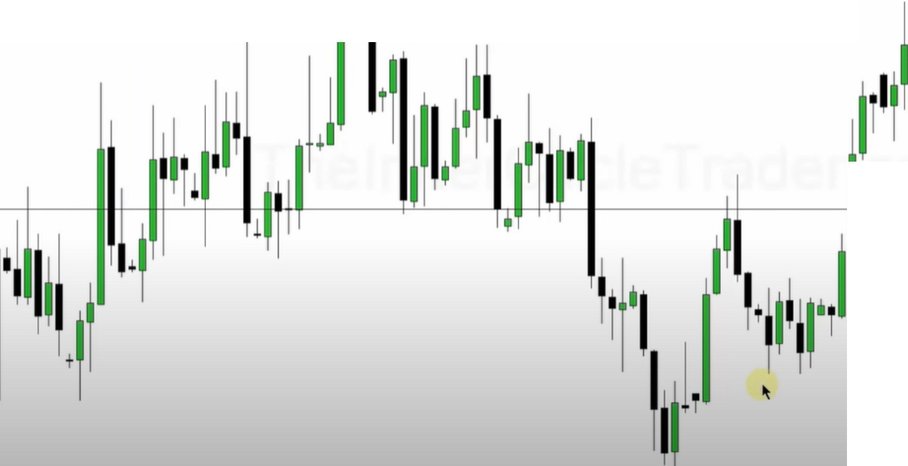

I

Everything above the monthly OB we can refine to a lower timeframe OB

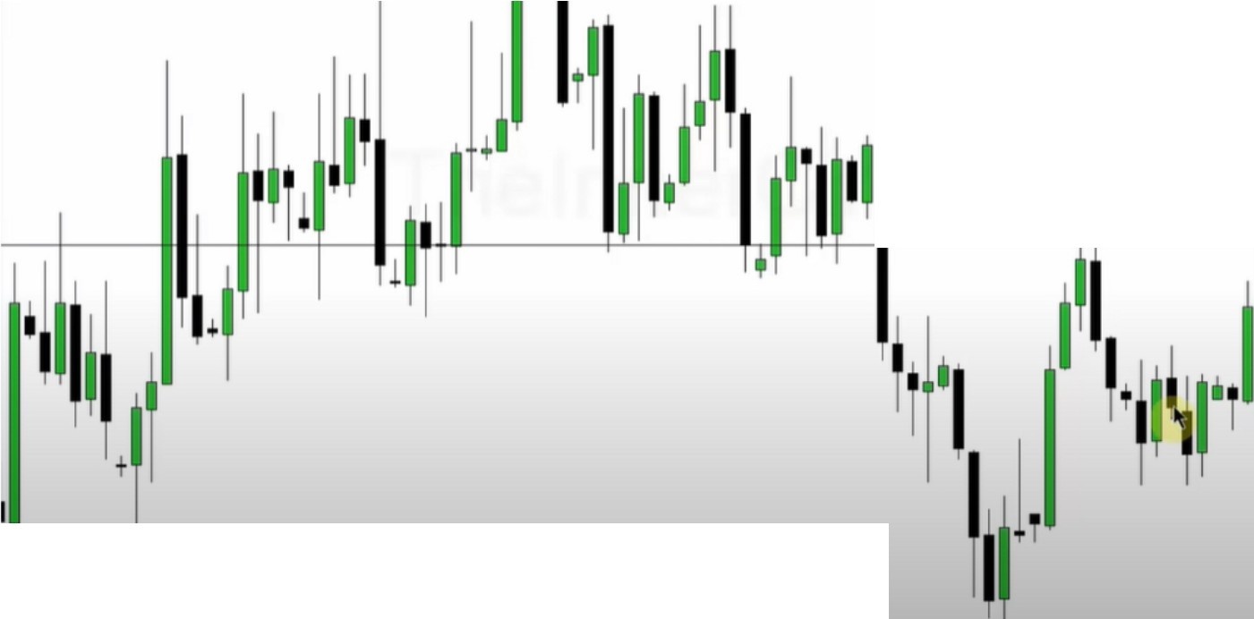

I'!

I

So we use the monhtly chart to get our orderblocks and define our range, and then we look for lower timeframes to get closer to the market and refine our risk

Youll knwo what levels to trade off of, this is a simple top down approach

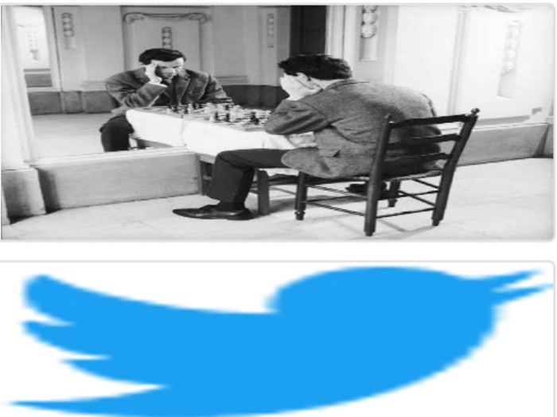Arjo I Twitter, lnstagram I Linktree

Linktree. Make your link do more.

, https://t.co/HhmmTN1fUI

JavaScript is not available.

*"JI* https://twitter.com/arjoio